Project Design Phase-II
Data Flow Diagram & User Stories

Date | 28 September 2026
Team ID | SWTID-2026-2169
Project Name | Import Data Using Transform Map
Maximum Marks | 4 Marks

Data Flow Diagrams:
A Data Flow Diagram (DFD) is a traditional visual representation of the information flows within the Import Data Using Transform Map process in Service Now. A neat and clear DFD depicts the right amount of the system requirement graphically. It shows how data enters the system from external sources such as Excel or CSV files, how it is loaded into the Import Set staging table, how the Transform Map changes the data by mapping source fields to target table fields, and where the final data is stored in the target table (e.g., Incident, User, or Group). It also shows how errors and skipped records are logged in the Transform History for review.

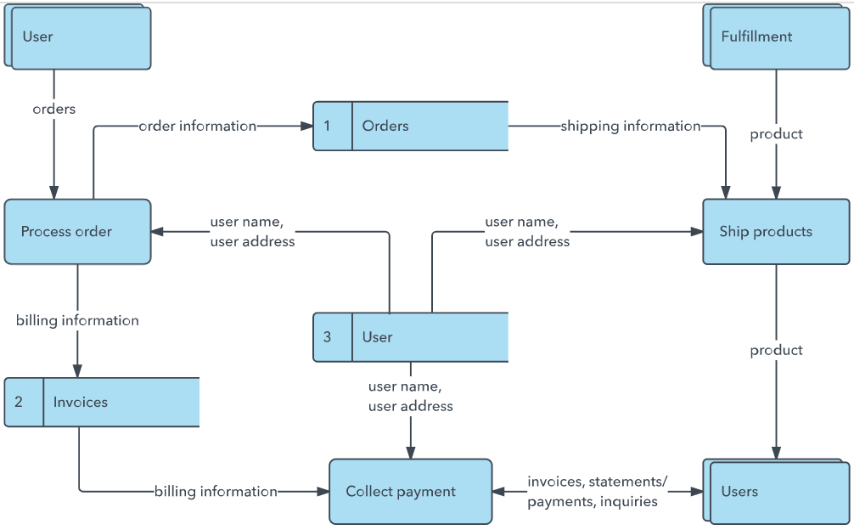

Example: (Simplified)



User Stories
Use the below template to list all the user stories for the product.
User Type | Functional Requirement (Epic) | User Story Number | User Story / Task | Acceptance criteria | Priority | Release
Customer (Mobile user) | Registration | USN-1 | As a user, I can register for the application by entering my email, password, and confirming my password. | I can access my account / dashboard | High | Sprint-1
Admin |  | USN-2 | As a user, I will receive confirmation email once I have registered for the application | I can receive confirmation email & click confirm | High | Sprint-1
  Import Data
Admin | Transform Map | USN-3 | As a user, I can register for the application through Facebook | I can register & access the dashboard with Facebook Login | Low | Sprint-2
Admin | Transform Map | USN-4 | As a user, I can register for the application through Gmail | I can upload the file and see the records in the import set table | Medium | Sprint-1
Admin (Data Uploader) | Login | USN-5 | As a user, I can log into the application by entering email & password | I can access the instance with valid credentials | High | Sprint-1
Admin (Data Uploader) | Dashboard | USN-2 | As an admin, I can view the Import Sets and Transform History on the dashboard | I can see the import status (Loaded, Processed, Error) | Medium | Sprint-1
Customer (Web user) | Data Source | USN-3 | As an admin, I can create a Data Source and upload an Excel/CSV file |  | High | Sprint-1
  The file is attached and the data source is saved successfully
Customer Care Executive |  | USN-4 | As an admin, I can load the file data into the Import Set (staging) table | The records appear in the staging table | High | Sprint-1
  Import Set | High | Sprint-1
Data Analyst (Import Operator) | Transform Map | SN-5 | As an analyst, I can create a Transform Map and map source fields to target table fields | The field mappings are saved and shown clearly | High | Sprint-2
Data Analyst (Import Operator) | Coalesce | USN-6 | As an analyst, I can set coalesce fields to avoid duplicate records |  | Medium | Sprint-2
  Existing records are updated and no duplicates are created
Data Analyst (Import Operator) |  | USN-7 | As an analyst, I can run the transform to load the data into the target table (e.g., Incident, User) | The data is inserted or updated in the target table | High | Sprint-2
  Run Transform
Administrator (System Admin) | Access Control | USN-8 | As an administrator, I can assign roles and ACLs so only authorized users can run imports | Unauthorized users cannot access import features | High | Sprint-3

